KLE Society's

KLE Technological University



**WEB TECHNOLOGY LAB**

**Activity: Structured enquiry**

**Raita Samparka Kendra**

**Bachelor of Engineering**

**In**

Computer Science and Engineering

**Submitted By**

**Team No: 05**

### pradeep Chegur 01fe19bcs294

### praveen takkannavar 01fe19bcs298

### Swagat ingalagaon 01fe19bcs299

### Naveen doddamani 01fe19bcs305

Faculty In charge

Prof. Manjula Pawar

SCHOOL OF COMPUTER SCIENCE & ENGINEERING

HUBLI–580 031 (India).

Academic year 2021-22

**PROBLEM STATEMENT**

**Raita Sampark Kendra:**

**-** Farmers will buy the fertilizers at RSK, in order to purchase they have to registered by the executives.

- Farmers should complete the KYC of his/her farm (register the farm details, property id, area etc.), a farmer can register one or more farm land.

- Executives will make an entry of each purchase made by the farmer along with the crop details.

- Maintain the history of the crops in their farm which will help them to claim insurance in case of disaster.

**Framework Chosen:**

1. Angular js
2. JS(Express)
3. HTML
4. CSS

**Methodology Adopted:**

Incremental model:

1. It is a process of software development where requirements are broken down into multiple standalone modules of software development cycle
2. Incremental development is a development approach that slices the product into fully working slices the product that are called increments
3. Each new increment builds on top of the existing released functionality
4. Incremental development is done in steps from analysis design, implementation, testing/verification, maintenance.

Fig 1. Home Page

* + Farmer has option to know about web site in About us option.
  + Schemes section has all schemes.
  + Executive login option is for executives to log in.

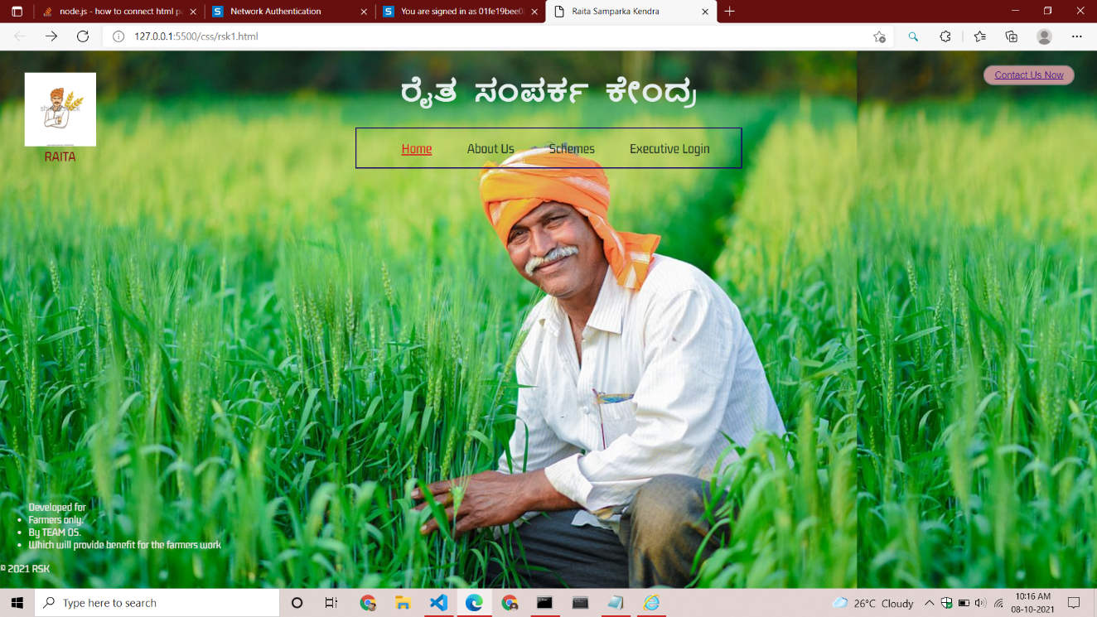

Fig 2. After clicking on About Us option the below page appears.

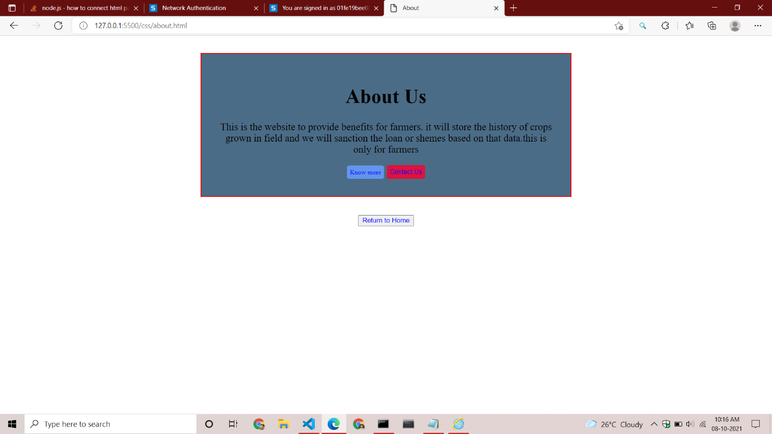

Fig 3. Different types of Schemes The farmer can avail for.

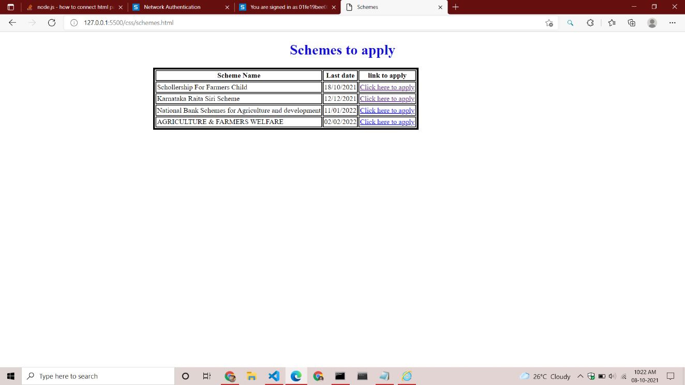

Fig 4.Executive Login Page for Executive to login.

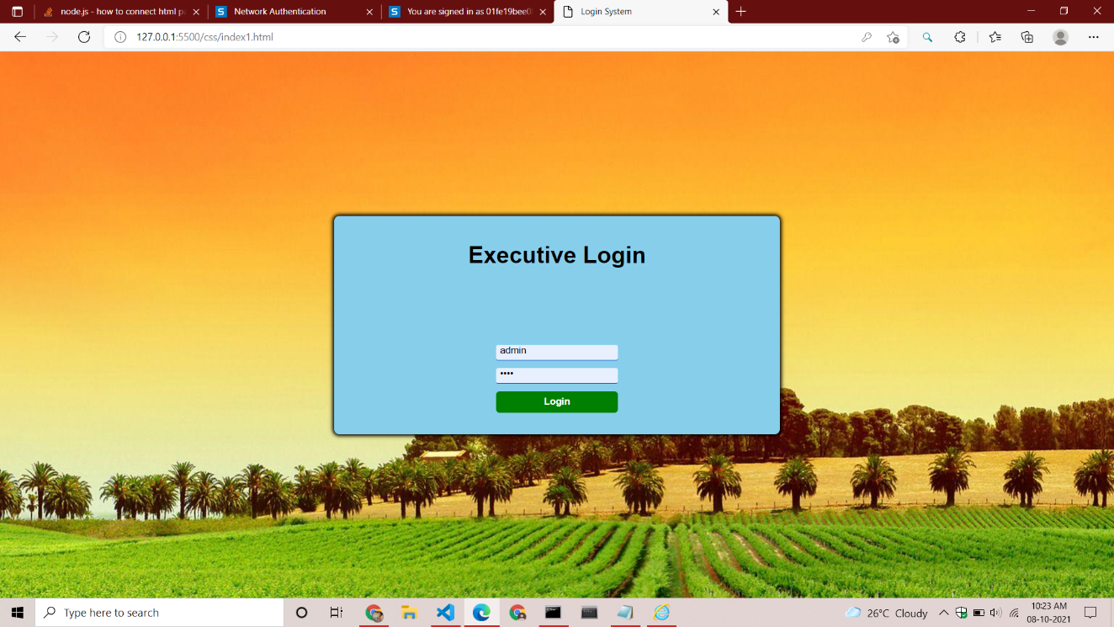

Fig 5. Registration Form which can be filled by Executive.

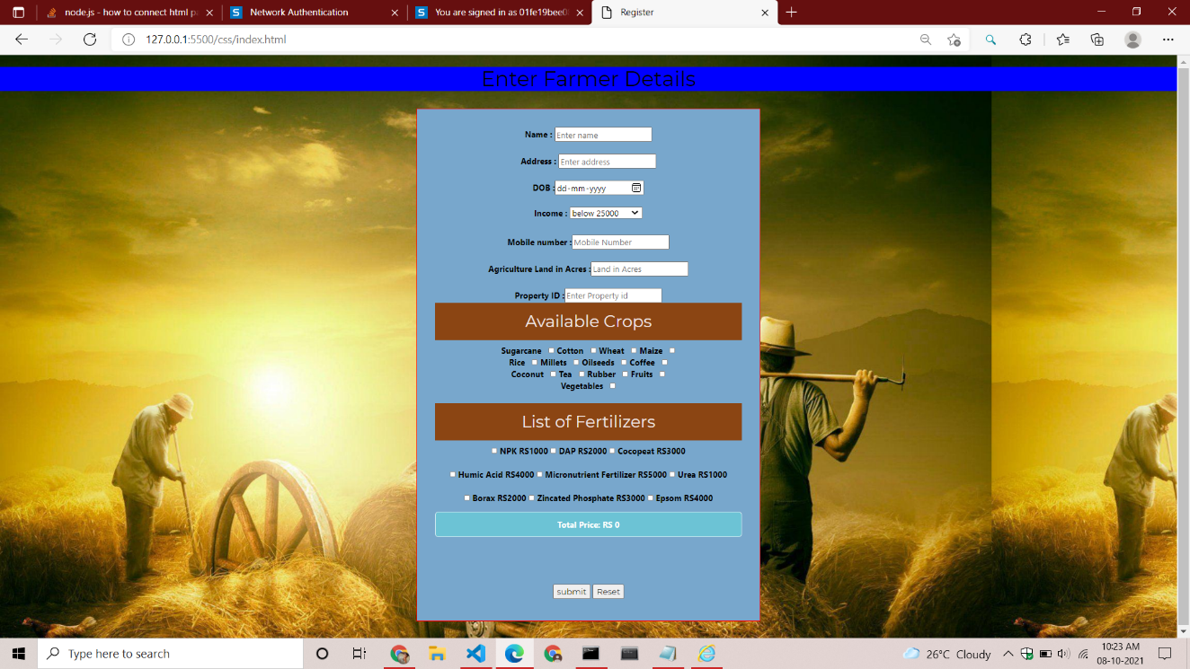

Fig 6.Contact details page

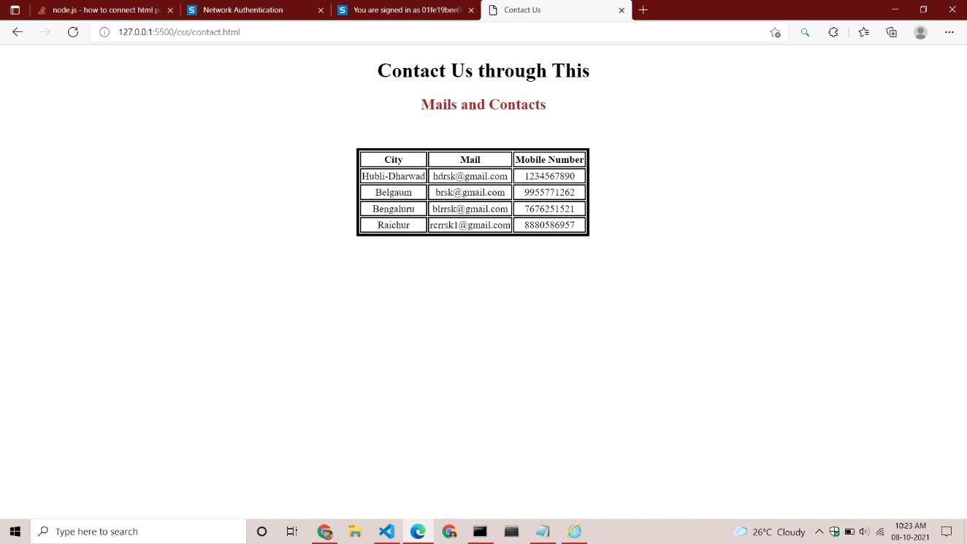

Fig 7. Database Page

